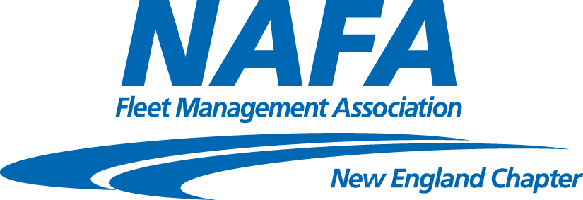
New England Chapter  Board Members  Officers:  Chair:  Karen E. Kearns  IGT Global Solutions  Vice Chair:  Peter Belloli  MilliporeSigma  Secretary:  Billie Munroe  Biogen  Treasurer:  Mary Ann Moeri  Element  Committee Chairpersons:  Membership:  Catherine A. Morrissey  Alumni  Kevin O’Loughlin  Sunovion Pharmaceuticals  Reception:  Karen Rasnick, CAFM  State of MA  Billie Munroe  Biogen  Programs:  Mary Ann Moeri  Element Corporation  Nancy James  J.J. Keller & Associates  Safety:  Allan Kirchner-Theriault  Dunkin’ Brands  Maintenance:  Stephen B. Russell  Alumni  Bill Brady  Cannistraro  Associates:  Tony Fina  Leaseplan  Web Site:  Peter Belloli  MilliporeSigma  At Large:  Greg Asadoorian  Alumni  Fred Davies  Town of Framingham, MA | Date: February 11, 2020  To: All Members, Associates, and Friends  From: Karen Kearns, NAFA New England Chapter Chair  Please join the NAFA New England Chapter at Merchants Fleet for an in depth look at Fleet Maintenance  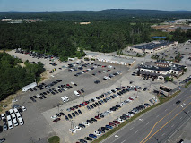  Wednesday March 11, 2020, 2020  Merchants’ new facility at 14 Central Park Drive, Hooksett NH 03106  They share their headquarters with United Healthcare  The education part of this meeting will focus on Fleet Maintenance. Evolving Maintenance: As technologies like autonomy mobile repairs, and electrification becoming a reality for today’s fleet how will vehicle maintenance need to evolve?  You’ll hear from several experts on fleet maintenance, from both the manufacturers side as well as leasing companies.  Agenda:  10:00-10:30am Registration & coffee  10:30 – 11:00am Introductions  11:00am – 11:30am Maintenance panel current trends  11:30am – 11:45am Break/ tour of new facility  12:00pm – 12:45pm Maintenance panel future of Maintenance  12:45pm Lunch  Please register by Friday, March 6, 2020 at our website: www.nafa-ne.org  For your reference, new registration fees for our meetings are as follows:  - NAFA Member $44  - Corp Colleague or Non-member $54  - Retired/Unemployed $20  SAVE THE DATES: Register now for the NAFA I&E-Indianapolis Indiana April 6-8th. May 20th Distracted Driving MilliporeSigma Bedford  Cancellation Policy: Cancellations must be received within 48 hrs. of meeting date to avoid registration fee. Cancellations can be made directly on the website or by emailing nafa.newengland@gmail.com

